This link opens to a video created at NASA by Gary. It is narrated by the legendary Walter Cronkite:

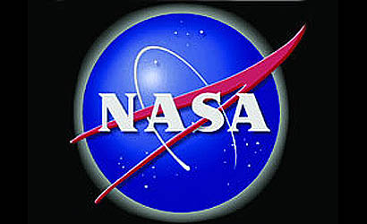
https://youtu.be/cr1dycs5gBQ

